# 3-D density structure of the Ross Sea basins, West Antarctica from constrained gravity inversion and their tectonic implications

Fei Ji1,2, Fei Li*1,Jin-Yao Gao*2, Qiao Zhang2 and Wei-Feng Hao1

*1 Chinese Antarctic Center of Surveying and Mapping, Wuhan University, Wuhan 430079, China. Email: fli@whu.edu.cn*

*2 Key Laboratory of Submarine Geosciences and Second Institute of Oceanography, State Oceanic Administration, Hangzhou 310012, China. Email: jygao@mail.hz.zj.cn*

**SUMMARY**

Crustal structure provides critical information for understanding the rifting and extensional history (i.e., the regional tectonic evolution) of the Ross Sea basins. Although this area has been investigated using large numbers of 2-D seismic reflection profiles collected during different cruises over the past several decades, its crustal-scale geological structure is still poorly known. This paper reports new information on the 3-D density structure of the Ross Sea obtained using gravity inversion performed with the GRAV3D algorithm and other forms of geophysical data, including free-air gravity anomaly, bathymetry and sediment thickness measurements. Combined with the published wide-angle refraction seismic results from the Antarctic Crustal Profile (ACRUP) project, Moho depths and upper and lower crustal thicknesses are inferred. Our results show that the inverted Moho depths and the boundaries of the upper and lower crust are largely consistent with the results of seismic studies. Under the sedimentary basins of the Ross Sea, the Moho generally occurs at depths of 13–18 km, corresponding to crustal thicknesses of 7–12 km; on the other hand, under basement highs, the Moho occurs at much greater depths of up to approximately 24–30 km in the northern part of the Coulman High, the Central High and Iselin Bank. Further, the stretching factors of the crust as a whole and the upper and lower crust (*βw*, *βu* and *βl*, respectively) are investigated by assuming the corresponding initial thickness. Depth-dependent stretching, in which crustal thinning increases with depth (i.e., the values of *βl* exceeds those of *βw* and *βu*), is observed under the Ross Sea basins. These discrepancies between the values of *β* for different parts of the crust suggest that the crust in the Ross Sea basins has experienced nonuniform crustal thinning. Together with published Curie point depth data, our results indicate that the Curie point lies beneath the Moho under the Victoria Land Basin (VLB) and Central High, suggesting that the uppermost mantle is magnetized. We speculate that this magnetism is the result of serpentinization.

**KEYWORDS:** Gravity anomalies; 3-D density anomaly model; Stretching factors; Ross Sea basins

## 1 INTRODUCTION

The Ross Sea region is located at one end of the Western Antarctic Rift System (WARS) and contains the Ross Sea basins, Western Marie Bryd Land and the northern part of the Transantarctic Mountains (TAMs) in Victoria Land. It connects the Southern Ocean to the north and the Ross Ice Shelf to the south. The formation of the Ross Sea basins, as a part of the largest continental rift system in Antarctica, involved two distinctive phases of extensional activity since the late Mesozoic that are characterized by a transition from initial diffuse extension to local extension in the western part of the Ross Sea (Salvini *et al.* 1997; Hamilton *et al.* 2001). Given its unusual extensional history, the tectonic evolution of the Ross Sea is complex.

Over the past several decades, various cruises that employ shipborne gravity and magnetic measurements and seismic reflection and broadband seismic surveys have been carried out in the Ross Sea. Examples include the Antarctic Offshore Stratigraphy (ANTOSTRAT) project (Cooper *et al.* 1987), the Antarctic Crustal Profile (ACRUP) project (Trey *et al.* 1999), the Transantarctic Mountains Seismic Experiment (TAMSEIS; Lawrence *et al.* 2006a; Lawrence *et al.* 2006b) and the Transantarctic Mountains Northern Network (TAMNNET, Hansen *et al.* 2016). Moreover, sediment cores from four DSDP sites in the Ross Sea (Leg 28, sites 270-273, Fig. 1) and several other sites in the McMurdo Sound region have been dated and provide insight into the tectonic history of Victoria Land Basin (VLB) and the glacial record of the Ross Sea. Nevertheless, our knowledge of the structure of the geological basement and the deeper crust in this area remains limited, due to the low quality and sparsity of valuable data. Some workers (Coren *et al.* 1994; Marson *et al.* 1997) have calculated the Moho depth of the Ross Sea using gravity data. The limited data coverage and the use of obsolete inversion techniques, such as those that do not consider the effects of sediment thickness, lead to less accurate inversion results. Chaput *et al.* (2014) estimated the crustal thickness beneath the West Antarctica using P-to-S receiver functions technique. An *et al.* (2015) inferred the Moho topography of the entire Antarctic Plate using the shear velocity model based on tomographic method. However, the spatial resolution of this work does not reflect the crustal structure within the Ross Sea region in detail. The data collected by the TAMSEIS seismic stations and those of the TAMNNET can provide more detailed information on the crustal structure, but the relevant stations are distributed sparsely along the coast and the hinterland of TAMs and show only the crustal thickness at the transition between the TAM and the Ross Sea; thus, they do not provide information on the crust that underlies the Ross Sea (Lawrence *et al.* 2006a; Hansen *et al.* 2016).

[Figure 1 near here]

To gain an improved understanding of the crustal structure in the Ross Sea basins and the crustal extension and thinning there, we present new data on Moho depths, crustal thicknesses and the stretching factors (*β*) of the crust as a whole and the upper and lower crust in this paper. We adopt the GRAV3D algorithm to invert the 3-D density structure in this area, based on gravity data and a reference model constrained by bathymetric and sediment thickness data. The Moho variations and crustal thicknesses are then identified and assessed in combination with seismic profiles. Subsequently, we estimate the upper and lower crustal thicknesses based on the OBS profile of ACRUP, and calculate their thinning factors. The extensional mechanisms and geodynamics of the Ross Sea basins since the Late Cretaceous are then discussed. Finally, through a joint analysis of the depths of the Curie point and the Moho, we study the geothermal structure and the origins of upper mantle magnetization.

## 2 GEOLOGICAL SETTING

The WARS is the one of the largest continental rift systems on Earth. Its length exceeds 3000 km, and width is 750 km to 1000 km. It divides Antarctica into the East Antarctic craton and West Antarctica (including Marie Byrd Land). The Ross Sea represents the broadest part of the WARS, bordering the Southern Ocean to the north. Evidence from geophysical investigations shows that the Ross Sea crust is made up of several north-south-trending sedimentary basins, the VLB, the Central Trough, the Eastern Basin and the Northern Basin and the Adare Basin, and two basement highs, the Coulman High and the Central High (Houtz & Davey 1973; Cande & Kent 1995). These sedimentary basins formed due to crustal extension and thinning within the Ross Sea region, most studies suggest that processes occurred during the early Late Cretaceous (Davey & Brancolini 1995; Salvini *et al.* 1997; Cande *et al.* 2000; Siddoway *et al*. 2004; McFadden *et al*. 2010). This major extension, probably associated with the seafloor spreading between New Zealand and Australia from Antarctica (Davey & Brancolini 1995), formed the wide Transantarctic Mountains rift margin and associated thinning of the west Ross Embayment (Heimann *et al*. 1994; Boger 2011). And this period of rifting almost covers the whole area of the West Antarctica (Siddoway *et al*. 2004). The separating between New Zealand and Marie Byrd Land indicates the seafloor spreading began approximately since 83 Ma ago (Cande *et al*. 2000).

After the seafloor spreading and the consequent extensional activity ended in the Late Cretaceous, a second phase of tectonics has occurred since Paleogene time (Huerta & Harry 2007). Compared with the first phase of extension, which was broadly distributed, the later phase of extension is focused primarily in the western Ross Sea, especially the northern part of the western Ross Sea and the VLB, and is associated with alkali basalt. Recent geophysical studies have shown that the western Ross Sea displays consistent high measured heat flow values (Risk & Hochstein 1974; Della Vedova *et al*. 1992; Morin *et al.* 2010), relatively slow estimated shear velocities (Lawrence *et al.* 2006b; Hansen *et al.* 2016) and inferred weak lithospheric mechanical strength (Ji *et al.* 2017). The Adare Basin, which lies within the northernmost portion of the study area, formed along one arm of a ridge-ridge-ridge triple junction, and its opening time is well constrained to 43–26 Ma by magnetic anomalies identified along the extinct Adare spreading axis (Cande & Kent 1995) that can be considered to represent the beginning of this Cenozoic extension. In contrast to the Adare Basin, the adjacent Northern Basin is located on the continental shelf. Although no direct evidence of the extensional history of the Northern Basin is available, the existence of continuous sedimentary sequences, magnetic anomalies and Bouguer gravity anomalies (Cande & Stock 2005; Damaske *et al.* 2007) that spread across the shelf break into the Northern Basin from the Adare Basin implies a possible linkage between the Adare seafloor spreading and the extensional tectonics of the western Ross Sea in the Neogene. The latest extensional event is located within the pre-existing VLB, and this crustal thinning led to the development of the Terror Rift. Evidence derived from seismic profiles indicates that the Terror Rift, which extends from north to south from the volcanoes of Mt. Melbourne to Mt. Erebus (Fig. 1), is a narrow and linear zone that is roughly 70 km in width and is associated with high-angle faults. These faults cut through the seafloor, suggesting that the second phase of extension may have continued episodically to the present (Cooper *et al.* 1987; Hall *et al.* 2007).

The use of surface wave tomography to study Antarctica and the surrounding oceans began many years ago (Danesi & Morelli 2001; Ritzwoller *et al.* 2001). As the number of seismic stations and recorded seismic events has increased, the resolution of inverted velocity models of the TAMs and the Ross Sea has gradually increased (Lawrence *et al.* 2006a; Lawrence *et al.* 2006b; An *et al.* 2015; Hansen *et al.* 2016). Studies that incorporate receiver function analyses show that the crustal thickness varies from uniform 35 km beneath the East Antarctica to only approximately 20 km in the adjacent Ross Sea, indicating a 35% crustal extension if we consider uniform crustal extension. Lithospheric modelling studies suggest that the average *β* values from three profiles in the Ross Sea basins vary from 2.3 to 2.8, corresponding to 115% to 140% extension since the Mesozoic extensional activity (Busetti *et al.* 1999). Trey *et al*. (1999) show that the *β* is higher in the VLB and reaches up to 4, assuming an initial thickness of 40 km. Fitzgerald *et al*. (1986) and Behrendt *et al.* (1991) argue that the total amount of extension has not been confirmed; however, most workers estimate that 200–400 km of extension has occurred in the Ross Sea region since the late Mesozoic, of which approximately 180 km occurred during the Eocene and Oligocene (Decesari et al., 1997; Cande *et al.* 2000). Hole & LeMasurier (1994) note that the geochemical characteristics of Miocene and younger alkaline basalts are uniform throughout West Antarctica and interpret this uniformity as evidence for minimal crustal extension during the late Cenozoic.

## 3 GRAVITY DATA

Free-air gravity anomalies over the Ross Sea were obtained from the latest 1×1-minute satellite altimetry data compiled by Sandwell *et al*. (2014; version 23.1), which incorporates new satellite data with high track densities from CryoSat-2 and Jason-1 into the older data and can thus reflect additional tectonic features buried by thick sediments. Due to their large-scale spatial coverage and high quality, the satellite-derived gravity data offer a means of revealing the regional crustal structure that is superior to that offered by shipboard gravity measurements. In oceanic regions, the three following density contrast interfaces are generally present below the water surface. First interface marks the boundary between the water and sediments; the second one delineates the contrast between the sediments and the oceanic crust; and the third one refers to the discontinuity between the crust and mantle, which is the Moho. Normally, the variations in the depth of the Moho are of greatest interest; these variations reflect the crustal structure and the tectonics in the study region, and the Moho plays a key role in rheology and geodynamics. Moho depths have been estimated in many regions globally in the last several decades using gravity inversion based on satellite-derived gravity data (Li *et al.* 2010, 2013; Prasanna *et al.* 2013). Moreover, the basement can also be characterized (Braitenberg *et al.* 2006), suggesting that the satellite-derived gravity data we employ also contain the high-frequency signal needed to acquire information on the density of shallow layers. Therefore, the gravity data we employ in this study can be used to invert density structure on different depth scales.

## 4 3-D INVERSION FOR DENSITY STRUCTURE

### 4.1 Method

Inverting for density structure is an iterative process in which a preferred 3-D density model is generated from an observed gravitational response. The iterative process terminates when the inverted density model provides a close match to the expected model. Because of the non-uniqueness of the inversion process, other geophysical signatures in addition to gravity are helpful in recovering more realistic density models that satisfy all of the observed geophysical signatures.

We employ the GRAV3D algorithm, a robust gravity inversion code developed by Li & Oldenburg (1996, 1998), to invert the gravity anomaly, and we incorporate other geophysical constraints as a priori model information to generate a 3-D subsurface density model. Gravity inversion of GRAV3D algorithm is an optimization problem and can be solved by finding the balance between to what extent the physical properties of the reference model fits that of the desired output model (i.e., the model norm) and to what extent the inverted model can generate synthetic data that fall within the error bounds of the observed data (i.e., the misfit). The model norm is defined by smoothing length scales in the three spatial directions, which can produce any desired model type (e.g., small, flat and blocky). At the same time, the GRAV3D algorithm attempts to minimize the misfit by causing the predicted gravity anomalies by the output density model to conform to those observed values. The difference between them is weighted by the reciprocal of the observed data errors so that the misfit for inversion is dimensionless and should be equal to the number of data points provided that the data errors are independent and Gaussian with zero mean (Li & Oldenburg 1998).

One of the problems contributing to the non-uniqueness of model solutions is that gravity data contain no inherent information at depth; thus, the inverted structures are concentrated at the surface of the model, where the data are most sensitive, regardless of the actual depth of the causative bodies (Welford & Hall 2007; Deng *et al.* 2014). In addition, the gravitational response decays rapidly with distance from the causative bodies below the surface. This behaviour destroys the equal probability of causative bodies occurring at different depths during the inversion. To address these problems, a depth weighting function has been implemented to compensate for natural decay by assigning an equal probability of the solution containing non-zero density values at different depths (Grav3D 5.0). Therefore, this function avoids the clustering of inverted bodies near the surface.

The GRAV3D mesh onto which the 3-D density anomaly distribution is modelled consists of rectangular prisms of a certain size; a constant density anomaly is assigned to each prism. To date, this method has been successfully applied to several passive continental margins, such as the South China, and the rifted continental margin of the Newfoundland, Irish and Labrador Sea, and these studies reflect the great advantages of inverting for structural features (Welford & Hall 2007; Welford *et al.* 2010; Welford & Hall 2013; Deng *et al.* 2014).

### 4.2 Reference model

To recover a more realistic density structure that is consistent with the tectonic structure of the study area, the construction of a reference density model that contains a priori geological and geophysical information must be incorporated into the inversion process. In this paper, we generate a 3-D reference density model based on the observed geophysical signature, e.g., bathymetry and sediment thickness (Figs. 2a and b). In order to perform the inversion, we discretize the model into a mesh that consists of a finite number of cells. From a computational perspective, a choice involving the tradeoff between computational speed and the resolution of the density estimates must be made; in this study, the mesh is constructed from flat cubes with a horizontal grid spacing of 5 km×5 km and a vertical step size of 500 m. The mesh covering our study area contains 201, 214 and 83 cells in the east-west, north-south and vertical directions, respectively.

[Figure 2 near here]

Larger gridded bathymetry and sediment thickness data are used in the inversion to avoid the edge effect; 6 padding cells are included in the horizontal direction, and 3 padding cells are included at the bottom of the reference density model (Grav3D 5.0). Welford & Hall (2007) suggest that the choice of the vertical extent of the mesh is very important in correctly delineating the size and position of anomalous rock bodies and should be tested through comparison with 2-D seismic profiles, because information on the variations in the Moho is not included in the reference density model before the inversion. Here, we tested different mesh depths (see Supplement Material) and selected the appropriate vertical extent of the mesh as 40 km that underlies the Moho depth. The generated mesh thus contains all of the bodies of anomalous rocks and density contrasts that correspond to the observed free-air gravity anomalies.

A bathymetric grid covering the Ross Sea is extracted from the General Bathymetric Chart of the Oceans (GEBCO) with a grid spacing of 0.5'. The study area mainly covers the continental shelf, where the depths are generally less than 1000 m. The deepest area on the continental shelf is the Drygalski Basin, which extends 150 km north from the Drygalski Ice Tongue to the northeast (Fig. 2a). The deep ocean basin northeast of the study area and continental shelf is characterized by deep ocean water reaching a maximum depth of 4000 m. The seafloor bathymetry is incorporated into the reference density model as Layer 1, and the density of seawater is set to 1030 kg/m3 with ±1 kg/m3 as the upper and lower bounds. The sediment thickness model (Fig. 2c) is taken from the total sediment thickness grid compiled by Lindeque *et al.* (2016). They used previous data sources from ANTOSTRAT (1995) and a part of the multichannel seismic data collected in the Ross Sea and the surrounding areas to obtain the depth to the acoustic basement using the time-depth conversion technique. The final data are resampled into 5×5 km grids using polar stereographic projection. Accumulations of sediment exist in four sedimentary basins, of which the VLB and the Eastern Basin are the primary areas; the sediment in these two basins is up to 7 km in thickness. In addition, the Central Trough and the Northern Basin are secondary areas, where the thickness of the sediment is 3–5 km. These gridded data are compiled into the reference density model as Layer 2, which underlies the seawater. It is important to note that, unlike seawater that has a fairly constant density, the density of sediment varies sharply with depth due to the compression effect, which contributes greatly to the observed gravitational response (Cowie & Karner 1990; Engen *et al.* 2006). For the sediment density, we employed the sediment compaction model (Sclater & Christie 1980) which represents the exponential reduction of the initial sediment porosity ($φ_{0}$) with depth and is expressed as

$ρ_{z}=φ_{0}e^{-\frac{z}{d}}ρ_{f}+ρ_{g}\left(1-φ_{0}e^{-\frac{z}{d}}\right)$ (1)where $ρ_{f}$ is the fluid density (which refers to seawater in this study) and is set to 1030 kg/m3, and d is an empirical constant that is related to depth decay. $ρ_{g}$ represents the grain density, and we set this variable to 2800 kg/m3, close to the crustal density, because $ρ_{z}$ tends to become equal to $ρ_{g}$ with depth. Considering that equation (1) is a theoretical model, we allow the sediment density to vary within ±200 kg/m3 and make the maximum density of the sediment is not greater than that of the crust (Fig. 3).

[Figure 3 near here]

Finally, the Moho depth is the last density contrast in the density reference model. The variations in the Moho depth under the continental shelf of the Ross Sea cannot be extracted from broadly distributed multichannel seismic data. Using Rayleigh waves received by seismic stations deployed in Antarctica, a 3-D shear velocity model covering the entire Antarctic Plate has been inverted and constructed by An *et al.* (2015), and crustal thickness were estimated using a weighted average of the depths based on the depth of several velocities in the vicinity of the possible Moho. The crustal thickness retrieved using this velocity model is approximately 20 km, generally consistent with the results obtained using wide-angle refraction profiles (Trey *et al.* 1999). However, the Moho depth was not incorporated into the reference density model used in our reference model, for the detailed reasons are given by Welford *et al*. (2010). Given that changes in crustal density vary within the ranges between 2650 kg/m3 and 2950 kg/m3 under normal conditions, the crust can be assigned a background density of 2800 kg/m3 with a limiting range of ± 150 kg/m3. Because the goal of our study is to determine the density structure, we consider the crust and mantle to be Layer 3, in which there is on density contrast and we set it homogeneous. Generally, a reasonable density of lithospheric upper mantle is often assumed as 3200 kg/m3 in gravity surveys and this quantity can be allowed to vary by ±300 kg/m3. Therefore, based on the values of background density, the upper and lower bounds for Layer 3 are -150 kg/m3 to +700 kg/m3, which aids in flexibly adjusting to density anomalies in Layer 3 during inversion and making the reproduced gravity response within an acceptable tolerance range. So far, reference density models have been constructed with three layers of different materials with different densities from top to bottom. In addition to the reference density model, the GRAV3D inversion process requires an initial physical property model that also incorporates specific bounds to speed up the inversion. Here, we employ a simple method and use the reference density model built in this section (reference density is 2800 kg/m3) as the initial model during the inversion.

### 4.3 Inversion results

#### *4.3.1 Uncertainty of the results*

Using the reference model and the boundary conditions that control the ranges of variation in the density within each cell, we obtain a 3-D density anomaly model (Fig. 4) that is constrained by the gravity data. The padded area is removed in the following sections to better analyse the inversion results. During the inversion process, the generated 3-D density anomaly model is smoothed over length scales of 65 km in the west-east and north-south directions and 5 km in the vertical direction.

[Figure 4 near here]

To assess the uncertainty of the final results, we then calculate the gravity anomalies generated by the 3-D density anomaly model. Fig. 5a shows the predicted data and the misfit between the observed and predicted gravity anomalies. The ranges and trends of the predicted data are highly consistent with the observed gravity anomalies and reflect the major gravity features. Examples include the positive linear high gravity anomalies along the Northern Basin, Central Trough and the Iselin Bank and the negative anomalies in the deep ocean basin. The discrepancies between the observed and predicted gravity anomalies are larger where the bathymetry varies strongly, such as the continental slope, than in the extensional basins of the Ross Sea. Welford and Hall (2007) suggested that short wavelength vibrations are a direct result of blocky mesh parameterizations and of imposing fixed limitations on seawater and (to a lesser extent) on the underlying sedimentary layers of the reference density model. Moreover, we argue that the degree of discretization of the reference model, i.e., immoderate gridding spacing, may contribute to discrepancies in local regions. In general, the inverted density anomaly model is able to reproduce the local and regional gravity observations within our study area, and there are no regional trends in the corresponding misfit.

[Figure 5 near here]

The OBS profile obtained by Trey *et al*. (1999) reveals the crustal structure from Ross Island to the west to the Eastern Basin to the east. This profile provides a means of accessing the inverted density anomaly model and can be used to identify the topography of the Moho and the intra-crustal boundary between the upper and lower crust. Fig. 6a shows vertical slices through the inverted density model along the OBS profile. As Welford *et al.* (2010), Welford & Hall (2013) and Deng *et al*. (2014) pointed out, although the Moho refers to the discontinuity or transition in seismic velocities between the crust and the mantle, an appropriate density contrast can be taken to represent the Moho, referred to as Moho-proxy depth by Welford *et al.* (2010), Welford & Hall (2013), if we assume that the Moho-proxy represents the variations in the depth of the Moho and is the primary cause of the sub-basin mass variations. Through comparison with the results of OBS profile, we select the density contours corresponding to 2890 kg/m3 and 2710 kg/m3 to represent the depths of the Moho and the boundary between the upper and lower crust, respectively. As shown in Fig. 6a, the intra-crustal boundary displays excellent agreement with the selected density contour. Our Moho depths are largely consistent with those obtained by OBS profile, especially in the VLB, the Coulman High and the Central Trough; the discrepancy is approximately 2–3 km in the Eastern Basin, which is also acceptable, given the accuracy of gravity inversion. Nevertheless, significant differences occur in the Central High, where the Moho surface inferred by OBS profile is quite flat, whereas that obtained using gravity inversion increases gradually from west to east. Even though many broadly distributed seismic measurements have been carried out throughout the Ross Sea, further assessment of our results is challenging; the Moho reflections in many seismic profiles cannot be identified with confidence, due to limited penetration depths of reflection profiles and presence of multiples (e.g., Salvini *et al.* 1997; Granot *et al.* 2010).

[Figure 6 near here]

#### *4.3.2 Variations in Moho depth and crustal thickness*

The Moho depths in the Ross Sea obtained by the GRAV3D algorithm are presented in Fig. 7a. The results show that, under the Ross Sea, the depth to Moho varies from 13 km to 30 km and correlates well with regional tectonic features identified by seismic studies. Shallow Moho depths (less than 18 km) dominate in the north-south-striking sedimentary basins, such as the VLB, the Central Trough, and the Northern Basin, suggesting that the thin crust is the consequence of episodic extensional tectonics. Compared with the other basins, the variations in the Moho depth in the Eastern Basin appears quite flat, and remain at approximately 18 km. In contrast, the Iselin Bank is characterized by greater depths to the Moho (~30 km), and the deeper values extend to the Central High to the south. Cande & Stock (2004) suggested that the Iselin Bank separated slowly from northern Victoria Land and was adjacent to the continental margin of Cape Adare before 61.1 Ma. Consequently, we suggest that the relatively large Moho depths within Iselin Bank may indicate only minimal extension of the continental crust. Another north-south-striking area, Hallett Ridge (not marked in Fig. 7 due to its small scale), that displays large Moho depths is located between the Northern Basin and the Northern Central Trough. The positive misfits in this area (Fig. 5b) reflect the predicted gravity anomalies are lower than the observed values, which cause the inverted Moho topography to deepen.

[Figure 7 near here]

The crustal thickness of the Ross Sea basins is obtained by subtracting the depth to basement (Fig. 2d) from the Moho depth (Fig. 7b). This surface displays similar trends as the variations in the Moho depth, but its gradients are sharper, which is driven by the different wavelengths of the Moho depth and the depth to basement. Relatively thin crust occurs within the several sedimentary basins; the thinnest crust (~7 km) is observed in the VLB, after the removal of extremely thick sediment (Cooper *et al.* 1987). In the other sedimentary basins, the crustal thickness generally changes between 10 km and 12 km, whereas in the Coulman High, the Central High and the Iselin Bank to its north, the crustal thickness is very large and can reach 28 km. Seismic stations are currently deployed along the TAM front, 50 km from the coast. Studies of the Southern and Northern TAMs based on seismic data from TAMSEIS and TAMNNET suggest that the crustal thicknesses along the coastline at a latitude of approximately 74 °S–76 °S are relatively flat and vary from 18 km to 22 km (Lawrence *et al.* 2006a; Hansen *et al.* 2016); these values are consistent with our results in this vicinity. The deep ocean basin, which is categorized as oceanic crust based on its distinct age isochrones (Cande & Kent 1995), is generally underlain by relatively thin crust that averages approximately 9-12 km in thickness. On the other hand, an area located in the central part of the deep ocean basin exhibits local considerable thicknesses that range up to 21 km. Both the bathymetry and sediment thicknesses in this zone show few changes. However, one of the most striking features on the free-air gravity anomaly map (Fig. 2b) is three roughly parallel northeast-southwest-trending zones of low values. These significant changes in the deep ocean basin may reflect old fracture zones and extinct spreading centers from an early age (Cande & Stock 2004). This study focuses primarily on sedimentary basins on the continental shelf, so the deep ocean basin is excluded from the following discussion; considering the same density interface in the oceanic area and beneath the continental shelf may be inappropriate. The Moho density contour we employ here is selected to ensure that the results in the Ross Sea basins will be more reasonable.

#### *4.3.3 Variations in the upper and lower crust*

Combining the intra-crustal boundary between the upper and lower crust from the results of ACRUP in Fig. 6, we extract the 2710 kg/m3 contour from the 3-D density anomaly model discussed in section 4.4.1 as the interface between the upper and lower crust (Fig. 8). The results can be further used to analyse the variations in individual crustal layers and their structural characteristics in the Ross Sea basins.

[Figure 8 near here]

The variations in the thicknesses of the upper (Fig. 8a) and lower crust (Fig. 8b) exhibit similar trends at the regional scale, and they are quite consistent with the locations of the sedimentary basins and basement highs between them. In an additional analysis, we find that, in the VLB, the upper crust is thinner than the lower crust by 1.5 km. The occurrence of greater amounts of brittle extension in the upper crust may be related to the second phase of crustal extension that occurred in the western Ross Sea during the Cenozoic (Salvini *et al.* 1997). In addition, the lower crust in the Central High and the Iselin Bank to its north is obviously thicker than the upper crust, and the corresponding values increase northward from 10 km to 15 km and from 13 km to 18 km, respectively. Within the remainder of the study area, the differences between Figs. 8a and b are very slight, but the upper crust is slightly thinner than the lower crust.

## 5 DISCUSSION

### 5.1 Variations in β - nonuniform crustal thinning?

The parameter *β* is significant in estimating the amount of crustal thinning and identifying extension mechanisms. Considering that the upper and lower crust differ in terms of their physical properties and compositions, we attempt to separately determine the stretching factors of the upper crust (*βu*) and the lower crust (*βu*), as well as that of the crust as a whole (*βw*). Different methods are currently used to calculate these parameters. Several researchers (Kusznir & Ziegler 1992; Davis & Kusznir 2004) have employed the geometric parameters of faults identified in seismic profiles, such as their locations, dips, and heaves, to estimate *βu*. However, faults are frequently affected by subsequent geological events that change their geometric parameters (Davis & Kusznir 2004) and contaminate the final values calculated using this method. Additionally, many faults, especially small-scale faults, go unrecognized in seismic profiles because of the limitations of seismic imaging; thus, brittle extension is often significantly underestimated (Reston 2005; Reston 2007). In this paper, we estimate the values of *βw*, *βu* and *βl* based on the thicknesses of the crust as a whole and the upper and lower crust (Figs. 7b and 8) using McKenzie’s (1978) pure shear model, in which *β* is calculated as the initial crustal thickness before stretching divided by the post-rift crustal thickness. The most appropriate estimate for the initial crustal thickness can be found in the adjacent East Antarctic, which was once bound to WARS before the late Cretaceous extension (Behrendt *et al.* 1991; Davey & Brancolini 1995). We assume an initial crustal thickness of 35 km, based on seismic evidence (Lawrence *et al.* 2006a; An *et al.* 2015) and gravity inversion (Block *et al.* 2009), which reveal that the adjacent East Antarctic has a uniform crustal thickness. The OBS profile from ACRUP shows that an S-wave velocity of 3.6 km/s is the boundary that divides the upper and lower crust (Trey *et al.* 1999). The 3.6 km/s contour separates the published 3D shear velocity model into the upper and lower crust, and the proportion is approximately 2:1 in East Antarctica (see transect D-D' and N-N' in the work of An *et al.* 2015). Therefore, we further suggest the initial upper and lower crustal thicknesses are 12 km and 23 km. Based on these initial thicknesses, we estimate the values of *βw*, *βu* and *βl* (Fig. 9).

[Figure 9 near here]

To best illustrate the amount of extension within different parts of crust, we use a standard colour bar in Fig. 9. The *β* values are significantly elevated in the sedimentary basins of the Ross Sea compared to the basement rises and the Iselin Bank. The values of *βw* in the sedimentary basins (e.g., the VLB, the Central Trough and the Eastern Basin) generally exceed 3 and can be as high as 5, which suggests that the crust beneath the Ross Sea basins has been significantly thinned, due to the process of extension. Moreover, the values of *βl* are easily shown to be generally higher than those of *βu,* and *βw* displays moderate values, indicating that the stretching of the crust increases with depth, and the ductile lower crust has thinned to a much greater degree than the brittle upper crust (Driscoll & Karner 1998). For example, if we compare the differences between *βu* and *βl* in the VLB, we conclude that most partsof the VLB differ by more than 30%. On the other hand, in the Central Trough and the Eastern Basin, the discrepancies are larger, and the lower crust appears to have been stretched to a greater degree than the upper crust, suggesting greater nonuniformity with depth (Fig. 10). We interpret the different degree of discrepancies in the sedimentary basins of the Ross Sea as likely to be the consequences of thermal rejuvenation in the western Ross Sea (Ji *et al.* 2017). The Cenozoic extensional activity weakened the lithosphere and isostatically adjusted the depth of the Moho (Karner *et al.* 2005), resulting in the less nonuniform extension in the VLB compared with the Central Trough and the Eastern Basin. In addition, the extracted profiles in Fig. 10 show that the crustal stretching increases from the eastern to the western Ross Sea, and these results are similar to those obtained by Busetti *et al.* (1999). They conclude that the values of *βw* of the first phase of extension in the sedimentary basins of the Ross Sea changes between 2 and 4, suggesting this extensional event affected the entire Ross Sea basins. The concentrated stretching in the western Ross Sea suggests that the two phases of tectonic activity that have occurred in this area contributed to the crustal thinning. In general, we conclude that discrepancies in extension consistently exist between the crust as a whole and the upper and lower crust, and that the entire crust of the Ross Sea may have experienced nonuniform thinning. The mechanism responsible is depth-dependent stretching (Davis & Kusznir 2004; Reston 2007; Crosby *et al.* 2011).

[Figure 10 near here]

Such discrepancies in extension have been noted in many other rifted margins globally; examples include the South China margin (Clift & Lin 2001), the Iberian margin and the Vøring rifted margin (Roberts *et al.* 1997; Davis & Kusznir 2004). There are a few possibilities to explain the causes. Morley & Westaway (2006) claim that depth-dependent stretching can be explained as a consequence of post-rift subsidence involving the flow of the lower crust. Based on the results of a coupled modelling technique, they conclude that a lateral pressure gradient produced by surface processes drove the lower crust to flow out from beneath the basin, further thinning the crust by several kilometres. Clift *et al.* (2002) also identified weak, low-viscosity lower crust along the South China Margin. The variations of the elastic effective thickness over the Ross Sea show that the flexural rigidity in the central and eastern Ross Sea was relatively high when the Cenozoic loadings occurred (Ji *et al.* 2017); thus, the lower crust flowed with difficulty out of the basin driven by the sediment loading during the post-rift stage. Moreover, the effect of isostatic adjustment on the crust, which aids the outflow of lower crustal material, is very limited given high mechanical strength. We therefore discard the possibility that the greater extension in the lower crust than the upper crust is related to the flow of the lower crust associated with the Eocene-Neogene sediment loading. The discrepancy observed in the Ross Sea is much more likely to have occurred during the syn-rift (late Mesozoic) stage than during post-rift sedimentation. Huismans & Beaumont (2011) explain the formation process of nonuniform extension using dynamical models. They conclude that the ‘a’ type model (Type 2), which involves a weak lower crust between the stronger upper crust and the lithospheric mantle, could also cause depth-dependent stretching, in which the upper crust thins slightly because its extension is distributed across a wide region, and the lower crust decreases in thickness or is removed. This process may be accompanied by intra-lithospheric decoupling. A direct evidence of melt-rich middle to lower crust arises from exposed mid-Cretaceous migmatite-cored gneiss dome in the Fosdick Mountains of Marie Byrd Land that coincides with onset of regional extension and opening of the WARS (*Siddoway et al.* 2004; *Siddoway* 2008; *McFadden et al.* 2010). The metamorphism and anatexis these rocks experienced require high temperature in excess of 800 °C which facilitates development of the lower crust flow during the process of Mesozoic lithospheric extension. Moreover, core complexes developed and high temperature metamorphism occurred in its conjugate Zealandia margin at the same time (*Schulte et al*. 2014). Consequently, we argue that relatively low-viscosity lower crust may have been present during the syn-rift period, thus leading to the observed discrepancy in extension. The results from numerical models also show the existence of decoupling between upper and lower crustal deformation (van Wijk *et al.* 2008). Additional information on pre-rift and syn-rift lithospheric properties, such as the rheological parameters and heterogeneity of the crust, are expected and they would help greatly in assessing the Mesozoic extensional history of the study region.

### 5.2 The Moho depth versus the Curie point depth

The Curie point depth can be taken to represent a magnetic surface below which pure magnetic minerals exceed a certain temperature (approximately 580 °C) and become demagnetized. Therefore, it serves as a good proxy for the thermal state and geodynamic evolution of the lithosphere and generally correlates well with heat flow (Li *et al.* 2010; Li 2011). Li *et al*. (2017) estimated Curie point depths globally using a centroid approach based on the radially averaged amplitude spectrum of total field magnetic anomalies and published a global reference Curie point depth model. The inverted Curie point depth values in the Ross Sea are shown in Fig. 11a. The Curie point depth varies between 9 km and 30 km in our study area, and most values are shallower than 20 km, except under northern Victoria Land and the Iselin Bank, where the Moho also deepens. The areas of Cenozoic extension, magmatism and volcanism in the western Ross Sea are consistent with the observed small values of the Curie point depth and the high heat flow values, e.g., in the Northern Basin, Melbourne volcanic province and Ross Island, indicating the presence of hot lithosphere (Lawrence *et al.* 2006b; Hansen *et al.* 2016; Ji *et al.* 2017); the minimum values appear under the Melbourne volcanic province of northern Victoria Land, where the young volcano MB and MTP is located. The similar Curie point depths in the Adare Basin and the Northern Basin suggest that the extensional activity associated with these two basins may have had a common origin and further support the idea of a strong kinematic linkage between them (Cande & Stock 2005; Damaske *et al.* 2007). However, unlike most sedimentary basins in the Ross Sea, the VLB exhibits relatively large Curie point depths, which also disagrees with the relationship with the measured high heat flow values (Li *et al.* 2010). We interpret these observations as the result of extremely thick sediments (Cooper *et al.* 1987).

[Figure 11 near here]

The relationship between the depths of the Moho and the Curie point has been used by some researchers to reveal the magnetization of the uppermost mantle (Li *et al.* 2010; Li *et al.* 2013). We compare the published Curie point depths from Li *et al*. (2017) with our Moho depths recovered using the GRAV3D algorithm, and the results are shown in Fig. 11b. We find that Curie point depth is greater than the Moho depth in the VLB and Central Trough, suggesting that the uppermost mantle in these basins should be magnetized, whereas the Curie point depth is closer to the Moho depth in the Eastern Basin and Northern Basin.Dyment *et al*. (1997) and Li *et al*. (2013) note that serpentinization may be a critical magnetic source in the uppermost mantle. Pérez-Gussinyé & Reston (2001) suggest that the crust as a whole tends to be brittle when the value of *βw* lies between 3 and 5, based on numerical models. During this process, faults that cut completely through the crust serve as conduits by which seawater enters the mantle, and this process can contribute to the serpentinization of the uppermost mantle. Fig. 9c shows that the value of *βw* in the above areas exceeds 3. Additionally, the OBS profile shows that the uppermost mantle beneath the VLB and possible Central Trough where limited refractions are modeled is characterized by the reduced velocities, e.g., 7.8 km/s and less. The observed low velocity zone in the uppermost mantle is a significant evidence of serpentinization (Miller & Christensen 1997; Mével 2003). Therefore, we favour the presence of magnetic uppermost mantle under the VLB and possible the Central High that result from a certain degree of serpentinization.

## 6 CONCLUSIONS

Using the GRAV3D algorithm, we combine gravity, bathymetry and sediment thickness data to obtain a new model of the 3-D crustal structure within the Ross Sea region. Combined with the evidence from ACRUP, we also estimate the Moho depths, the upper and lower crustal thicknesses and the corresponding stretching factors. Our results obtained from cross-sections of the inverted 3-D density anomaly model are consistent well with the depths of the Moho and the intra-crustal boundary determined from the OBS profile. The main points are as follows:

(1) The crust beneath the sedimentary basins in the Ross Sea displays significant thinning (with thicknesses of 7–12 km); of these basins, the VLB is characterized by the thinnest crust. In contrast, thick crust (with thicknesses of up to 28 km) is located under the Central High, the Coulman High and Iselin Bank. Additionally, the upper crust is generally thicker than the lower crust, and this difference is relatively large under Iselin Bank and the northern Central High.

(2) Assuming initial thicknesses for the crust as a whole and the upper and lower crust, we use the present thicknesses to estimate the stretching factors (*βw*, *βu* and *βl*) for the attenuated crust of the Ross Sea basins. The results indicate that, in our study area, *βl* > *βw* > *βu*. The discrepancies among *βw*, *βu* and *βl* show that the crustal thinning in the Ross Sea region is nonuniform. Relatively high values of the stretching factors are obtained in the western Ross Sea; we suggest that these high values are related to the two phases of extension that have occurred in the same place. Combined with studies of numerical modelling (Huismans & Beaumont 2011) and lithospheric mechanical strength (Ji *et al.* 2017), we speculate that the depth-dependent stretching is likely related to the presence of relatively low-viscosity lower crust during the syn-rift period.

(3) Comparing the depth of the Moho with that of the Curie point indicates that the depth of the Curie point exceeds that of the Moho in the VLB and Central Trough, implying that the uppermost mantle is magnetic. By combing with high value of *βw* and reduced seismic velocity in the uppermost mantle, we argue that this phenomenon could results from serpentinization.

## ACKNOWLEDGEMENTS

This research was supported by the National Science Foundation of China (grant numbers 41576069, 41706215 and 41531069). This paper benefited from discussions with Yangfan Deng, Tao Zhang and Zhaocai Wu. We are grateful to the University of British Columbia in Canada for providing us with the software library GRAV3D v5.0 that we used to perform the gravity inversions. All of the projected figures in this paper were made using GMT (Wessel & Smith 1998). We thank Prof Ritzwoller (the editor), Dr. Siddoway and Dr Welford for their valuable comments and suggestions that greatly improved the manuscript. The data used in this study are available from corresponding author upon request.

## REFERENCES

An, M., Wiens, D.A., Zhao, Y., Feng, M., Nyblade, A.A., Kanao, M., Li, Y., Maggi, A. & Lévêque, J.-J., 2015. S-velocity model and inferred Moho topography beneath the Antarctic Plate from Rayleigh waves, *J. Geophys. Res.: Solid Earth,* 120, 359–383.

ANTOSTRAT, 1995. Seismic stratigraphic atlas of the Ross Sea, in *Geology and Seismic Stratigraphy of the Antarctic Margin, Antarct. Res. Ser.,* vol. 68, edited by Cooper, A.K., et al., 22 plates, AGU, Washington, D. C.

Behrendt, J.C., LeMasurier, W.E., Cooper, A.K., Tessensohn, F., Tréhu, A. & Damaske, D., 1991. Geophysical studies of the west Antarctic rift system, *Tectonics,* 10, 1257–1273.

Block, A.E., Bell, R.E. & Studinger, M., 2009. Antarctic crustal thickness from satellite gravity: implications for the Transantarctic and Gamburtsev Subglacial Mountains, *Earth Planet. Sci. Lett.,* 288, 194–203.

Boger, S.D., 2011. Antarctica — Before and after Gondwana, *Gondwana Research*, 19, 335-371.

Braitenberg, C., Wienecke, S. & Wang, Y., 2006. Basement structures from satellite-derived gravity field: South China Sea ridge, *J. Geophys. Res.: Solid Earth,* 111, B05407.

Busetti, M., Spadini, G., Van der Wateren, F.M., Cloetingh, S. & Zanolla, C., 1999. Kinematic modelling of the west Antarctic rift system, Ross Sea, Antarctica, *Global and Planetary Change,* 23, 79–103.

Cande, S.C. & Kent, D.V., 1995. Revised calibration of the geomagnetic polarity timescale for the Late Cretaceous and Cenozoic, *J. Geophys. Res.: Solid Earth,* 100, 6093–6095.

Cande, S.C. & Stock, J.M., 2004. Cenozoic reconstructions of the Australia-New Zealand-South Pacific sector of Antarctica, in *The Cenozoic Southern Ocean: Tectonics, Sedimentation, and Climate Change between Australia and Antarctica*, pp. 5–17, eds. Exon, N.F., Kennett, J.P. & Malone, M.J., American Geophysical Union.

Cande, S.C. & Stock, J.M., 2005. Constraints on the timing of extension in the Northern Basin, Ross Sea, in *Antarctica: Contributions to Global Earth Sciences*, pp. 319–326, eds. Fütterer, D.K., Damaske, D., Kleinschmidt, G., Miller, H. & Tessensohn, F., Springer.

Cande, S.C., Stock, J.M., Müller, R.D. & Ishihara, T., 2000. Cenozoic motion between East and West Antarctica, *Nature,* 404, 145–150.

Chaput, J., Aster, R.C., Huerta, A., Sun, X., Lloyd, A., Wiens, D., Nyblade A., Anandakrishnan, S., Winberry, J.P. & Wilson, T., 2014. The crustal thickness of West Antarctica, *J. Geophys. Res.: Solid Earth*, 119, 1-18.

Clift, P. & Lin, J., 2001. Preferential mantle lithospheric extension under the South China margin, *Marine and Petroleum Geology,* 18, 929–945.

Clift, P., Lin, J. & Barckhausen, U., 2002. Evidence of low flexural rigidity and low viscosity lower continental crust during continental break-up in the South China Sea, *Marine and Petroleum Geology,* 19, 951–970.

Cooper, A.K., Davey, F.J. & Behrendt, J.C., 1987. Seismic stratigraphy and structure of the Victoria Land basin, western Ross Sea, Antarctica, in *The Antarctic Continental Margin: Geology and Geophysics of the Western Ross Sea*, pp. 27–76, eds. Cooper, A.K. & Davey, F.J., Circum-Pacific Council for Energy and Mineral Resources.

Coren, F., Marson, I., Štoka, M. & Zanolla, C., 1994. Computation of the Moho depths from gravity data in the Ross Sea (Antarctica), in *Gravity and Geoid IAGS*, Vol. 113, pp. 278–285, eds. Sünkel, H., Marson, I., Springer.

Cowie, P.A. & Karner, G.D., 1990. Gravity effect of sediment compaction: examples from the North Sea and the Rhine Graben, *Earth Planet. Sci. Lett.,* 99, 141–153.

Crosby, A.G., White, N.J., Edwards, G.R.H., Thompson, M., Corfield, R. & Mackay, L., 2011. Evolution of deep-water rifted margins: testing depth-dependent extensional models, *Tectonics,* 30, TC1004.

Damaske, D., Läufer, A.L., Goldmann, F., Möller, H.D. & Lisker, F., 2007. Magnetic anomalies northeast of Cape Adare, northern Victoria Lnortheast of Cape Adare, northern Victoria Laand (Antarctica), and their relation to onshore structure, in *Proceedings of the 10th ISAES*, pp. 5, eds. Cooper, A.K. & Raymond, C.R., USGS Open-File Report 2007-1047, Short Research Paper 016.

Danesi, S. & Morelli, A., 2001. Structure of the upper mantle under the Antarctic Plate from surface wave tomography, *Geophys. Res. Lett.,* 28, 4395–4398.

Davey, F.J. & Brancolini, G., 1995. The Late Mesozoic and Cenozoic structural setting of the Ross Sea region, in *Geology and Seismic Stratigraphy of the Antarctic Margin*, pp. 167–182, eds. Cooper, A.K., Barker, P.F. & Brancolini, G., Antarctic Research Series 68, AGU.

Davis, M. & Kusznir, N.J., 2004. Depth-dependent lithospheric stretching at rifted continental margins, in *Proceedings of the NSF Rifted Margins Theoretical Institute*, pp. 92–137, ed. Karner, G.D., Columbia University Press.

Decesari, R.C., Wilson, D.S., Luyendyk, B.P. & Faulkner, M., 2007. Cretaceous and Tertiary extension throughout the Ross Sea, Antarctica, in Antarctica: A Keystone in a Changing World – Online Proceedings of the 0th ISAES, edited by A.K. Cooper and C.R. Raymond et al., USGS Open-File Report 2007-1047, Short Research Paper 098, 6 p.

Deng, Y., Zhang, Z., Badal, J. & Fan, W., 2014. 3-D density structure under South China constrained by seismic velocity and gravity data, *Tectonophysics,* 627, 159–170.

Della Vedova, B., Pellis, G., Lawver, L.A. & Brancolini, G., 1992. Heat flow and active tectonics of the wetsern Ross Sea, in Yoshida, Y., Kaminuma, K. & Shiraishi, K. (eds) *Recent Progress in Antarctic Earth Science*. Tokyto: Terra Scientific, pp. 627-637.

Ding, W., Franke, D., Li, J. & Steuer, S., 2013. Seismic stratigraphy and tectonic structure from a composite multi-channel seismic profile across the entire Dangerous Grounds, South China Sea, *Tectonophysics,* 582, 162–176.

Driscoll, N.W. & Karner, G.D., 1998. Lower crustal extension across the Northern Carnarvon basin, Australia: evidence for an eastward dipping detachment, *J. Geophys. Res.: Solid Earth,* 103, 4975–4991.

Dyment, J., Arkani-Hamed, J. & Ghods, A., 1997. Contribution of serpentinized ultramafics to marine magnetic anomalies at slow and intermediate spreading centres: insights from the shape of the anomalies, *Geophys. J. Int.,* 129, 691–701.

Engen, Ø., Frazer, L.N., Wessel, P. & Faleide, J.I., 2006. Prediction of sediment thickness in the Norwegian-Greenland Sea from gravity inversion, *J. Geophys. Res.: Solid Earth,* 111, B11403.

Fitzgerald, P.G., Sandiford, M., Barrett, P.J. & Gleadow, A.J.W., 1986. Asymmetric extension associated with uplift and subsidence in the Transantarctic Mountains and Ross Embayment, *Earth Planet. Sci. Lett.,* 81, 67–78.

Granot, R., Cande, S.C., Stock, J.M., Davey, F.J. & Clayton, R.W., 2010. Postspreading rifting in the Adare Basin, Antarctica: regional tectonic consequences, *Geochem. Geophys. Geosyst.,* 11, Q08005.

GRAV3D, 2013. *A Program Library for Forward Modelling and Inversion of Gravity Data over 3D Structures*,Version 5.0 UBC- Geophysical Inversion Facility, Department of Earth and Ocean Science, University of British Columbia.

Hall, J.M., Wilson, T.J. & Henrys, S., 2007. Structure of the central Terror rift, western Ross Sea, Antarctica, in *Antarctica: A Keystone in a Changing World – Online Proceedings of the 10th ISAES*, eds Cooper, A.K. & Raymond, C.R., USGS Open-file Report 2007–1047, Short Research Paper 108.

Hamilton, R.J., Luyendyk, B.P., Sorlien, C.C. & Bartek, L.R., 2001. Cenozoic tectonics of the Cape Roberts rift basin and Transantarctic Mountains front, southwestern Ross Sea, Antarctica, *Tectonics,* 20, 325–342.

Hansen, S.E., Kenyon, L.M., Graw, J.H., Park, Y. & Nyblade, A.A., 2016. Crustal structure beneath the Northern Transantarctic Mountains and Wilkes Subglacial Basin: implications for tectonic origins, *J. Geophys. Res.: Solid Earth,* 121, 812–825.

Heimann. A, Fleming, T.H., Elliot, D.H. & Foland, K.A., 1994. A short interval of Jurassic continental flood basalt volcanism in Antarctica as demonstrated by 40Ar/39Ar geochronology, *Earth Planet. Sci. Lett.*, 121, 19-41.

Hole, M.J. & LeMasurier, W.E., 1994. Tectonic controls on the geochemical composition of Cenozoic, mafic alkaline volcanic rocks from West Antarctica, *Contrib. Mineral Petrol.,* 117, 187–202.

Houtz, R. & Davey, F.J., 1973. Seismic profiler and sonobuoy measurements in Ross Sea, Antarctica, *J. Geophys. Res.,* 78, 3448–3468.

Huerta A.D. & Harry, D.L., 2007. The transition from diffuse to focused extension: Modeled evolution of the West Antarctic Rift system, *Earth Planet. Sci. Lett.,* 255, 133-147.

Huismans, R. & Beaumont, C., 2011. Depth-dependent extension, two-stage breakup and cratonic underplating at rifted margins, *Nature,* 473, 74–78.

Ji, F., Gao, J., Li, F., Shen, Z., Zhang, Q. & Li, Y., 2017. Variations of the effective elastic thickness over the Ross Sea and Transantarctic Mountains and implications for their structure and tectonics, *Tectonophysics,* 717, 127–138.

Karner, G.D., Studinger, M. & Bell, R.E., 2005. Gravity anomalies of sedimentary basins and their mechanical implications: application to the Ross Sea basins, West Antarctica, *Earth Planet. Sci. Lett.,* 235, 577–596.

Kusznir, N. & Ziegler, P., 1992. The mechanics of continental extension and sedimentary basin formation: a simple-shear/pure-shear flexural cantilever model, *Tectonophysics,* 215, 117–131.

Lawrence, J.F., Wiens, D.A., Nyblade, A.A., Anandakrishan, S., Shore, P.J. & Voigt, D., 2006b. Upper mantle thermal variations beneath the Transantarctic Mountains inferred from teleseismic S-wave attenuation, *Geophys. Res. Lett.,* 33, L03303.

Lawrence, J.F., Wiens, D.A., Nyblade, A.A., Anandakrishnan, S., Shore, P.J. & Voigt, D., 2006a. Crust and upper mantle structure of the Transantarctic Mountains and surrounding regions from receiver functions, surface waves, and gravity: implications for uplift models, *Geochem. Geophys. Geosyst.,* 7, Q10011.

Li, C.-F., 2011. An integrated geodynamic model of the Nankai subduction zone and neighboring regions from geophysical inversion and modeling, *Journal of Geodynamics,* 51, 64–80.

Li, C.-F., Lu, Y. & Wang, J., 2017. A global reference model of Curie-point depths based on EMAG2, *Sci. Rep.,* 7, 45129.

Li, C.-F., Shi, X., Zhou, Z., Li, J., Geng, J. & Chen, B., 2010. Depths to the magnetic layer bottom in the South China Sea area and their tectonic implications, *Geophys. J. Int.,* 182, 1229–1247.

Li, C.-F., Wang, J., Lin, J. & Wang, T., 2013. Thermal evolution of the North Atlantic lithosphere: new constraints from magnetic anomaly inversion with a fractal magnetization model, *Geochem. Geophys. Geosyst.,* 14, 5078–5105.

Li, Y. & Oldenburg, D.W., 1996. 3-D inversion of magnetic data, *Geophysics,* 61, 394–408.

Li, Y. & Oldenburg, D.W., 1998. 3-D inversion of gravity data, *Geophysics,* 63, 109–119.

Lindeque, A., Gohl, K., Wobbe, F. & Uenzelmann-Neben, G., 2016. Preglacial to glacial sediment thickness grids for the Southern Pacific Margin of West Antarctica, *Geochem. Geophys. Geosyst.,* 17, 4276–4285.

Marson, I., Štoka, M., Velicogna, I., Coren, F. & Zanolla, C., 1997. Gravity, geoid, isostasy and Moho depth in the Ross Sea, Antarctica, in *Gravity, Geoid and Marine Geodesy,* Vol. 117, pp. 351–359, eds. Segawa, J., Fujimoto, H. & Okubo, S., International Association of Geodesy Symposia, Springer Berlin Heidelberg.

Mcfadden, R.R., Siddoway, C.S., Teyssier, C. & Fanning, C.M., 2010. Cretaceous oblique extensional deformation and magma accumulation in the Fosdick Mountains migmatite-cored gneiss dome, West Antarctica, *Tectonics*, 29, TC4022.

McKenzie, D., 1978. Some remarks on the development of sedimentary basins, *Earth Planet. Sci. Lett.,* 40, 25–32.

Mével, C., 2003. Serpentinization of abyssal peridotites at mid-ocean ridges, *Comptes Rendus Geoscience,* 335, 825–852.

Miller, D.J. & Christensen, N.I., 1997. Seismic velocities of lower crustal and upper mantle rocks from the slow-spreading Mid-Atlantic Ridge, south of the Kane Transform zone (MARK), in *Proceedings of the Ocean Drilling Program, Scientific Results*, Vol. 153, pp. 437–454, College Station, TX, USA.

Morin, R.H., Williams, T., Henrys, S.A., Magens, D., Niessen, F. & Hansaraj, D., 2010. Heat flow and hydrologic characteristics at the AND-1B borehole, ANDRILL McMurdo Ice Shelf Project, Antarctica, *Geosphere,* 6, 370–378.

Morley, C.K. & Westaway, R., 2006. Subsidence in the super‐deep Pattani and Malay basins of Southeast Asia: a coupled model incorporating lower‐crustal flow in response to post‐rift sediment loading, *Basin Research,* 18, 51–84.

Pérez-Gussinyé, M. & Reston, T.J., 2001. Rheological evolution during extension at nonvolcanic rifted margins: onset of serpentinization and development of detachments leading to continental breakup, *J. Geophys. Res.: Solid Earth,* 106, 3961–3975.

Prasanna, H.M.I., Chen, W. & İz, H.B., 2013. High resolution local Moho determination using gravity inversion: a case study in Sri Lanka, *Journal of Asian Earth Sciences,* 74, 62–70.

Reston, T., 2007. Extension discrepancy at North Atlantic nonvolcanic rifted margins: depth-dependent stretching or unrecognized faulting?, *Geology,* 35, 367–370.

Reston, T.J., 2005. Polyphase faulting during the development of the west Galicia rifted margin, *Earth Planet. Sci. Lett.,* 237, 561–576.

Risk, G.F. & Hochstein, M.P., 1974. Heat flow at Arrival Heights, Ross Island, Antarctica. New Zealand, *Journal of Geology & Geophysics*, 17, 629-644.

Ritzwoller, M.H., Shapiro, N.M., Levshin, A.L. & Leahy, G.M., 2001. Crustal and upper mantle structure beneath Antarctica and surrounding oceans, *J. Geophys. Res.: Solid Earth,* 106, 30645–30670.

Roberts, A.M., Lundin, E.R. & Kusznir, N.J., 1997. Subsidence of the Vøring Basin and the influence of the Atlantic continental margin, *Journal of the Geological Society,* 154, 551–557.

Salvini, F., Brancolini, G., Busetti, M., Storti, F., Mazzarini, F. & Coren, F., 1997. Cenozoic geodynamics of the Ross Sea region, Antarctica: crustal extension, intraplate strike-slip faulting, and tectonic inheritance, *J. Geophys. Res.: Solid Earth,* 102, 24669–24696.

Sandwell, D.T., Muller, R.D., Smith, W.H.F., Garcia, E. & Francis, R., 2014. New global marine gravity model from CryoSat-2 and Jason-1 reveals buried tectonic structure, *Science,* 346, 65–67.

Sclater, J.G. & Christie, P.A.F., 1980. Continental stretching: an explanation of the post‐Mid‐Cretaceous subsidence of the central North Sea Basin, *J. Geophys. Res.: Solid Earth,* 85, 3711–3739.

Schulte, D.O., Ring, U., Thomson, S.N., Glodny, J. & Carrad, H., 2014. Two-stage development of the Paparoa Metamorphic Core Complex, West Coast, South Island, New Zealand: Hot continental extension precedes sea-floor spreading by, 25 m.y., *Lithosphere*, 6, 177-194.

Siddoway, C. S., 2008. Tectonics of the West Antarctic Rift System: New light on the history and dynamics of distributed intracontinental extension, in Antarctica: A Keystone in a Changing World – Processdings of the 10th ISAES, edited by Cooper, A.K., Barrett, P.J., Stagg, H., Storey, B., Stump, E., Wise, W., pp. 91–114, The National Academies Press, Washington, D.C.

Siddoway, C.S., Baldwin, S.L., Fitzgerald, P.G., Fanning, C.M. & Luyendyk, B.P., 2004. Ross Sea mylonites and the timing of intracontinental extension within the West Antarctic rift system, *Geology*, 32, 57–60.

Trey, H., Cooper, A.K., Pellis, G., della Vedova, B., Cochrane, G., Brancolini, G. & Makris, J., 1999. Transect across the West Antarctic rift system in the Ross Sea, Antarctica, *Tectonophysics,* 301, 61–74.

van Wijk, J.W., Lawrence, J.F. & Driscoll, N.W., 2008. Formation of the Transantarctic Mountains related to extension of the West Antarctic rift system, *Tectonophysics,* 458, 117–126..

Watson, T., Nyblade, A., Wiens, D.A., Anandakrishnan, S., Benoit, M., Shore, P.J., Voigt, D. & VanDecar, J., 2006. P and S velocity structure of the upper mantle beneath the Transantarctic Mountains, East Antarctic craton, and Ross Sea from travel time tomography, *Geochem. Geophys. Geosyst.,* 7, Q07005.

Welford, J.K. & Hall, J., 2007. Crustal structure of the Newfoundland rifted continental margin from constrained 3-D gravity inversion, *Geophys. J. Int.,* 171, 890–908.

Welford, J.K. & Hall, J., 2013. Lithospheric structure of the Labrador Sea from constrained 3-D gravity inversion, *Geophys. J. Int.,* 195, 767–784.

Welford, J.K., Shannon, P.M., O'Reilly, B.M. & Hall, J., 2010. Lithospheric density variations and Moho structure of the Irish Atlantic continental margin from constrained 3-D gravity inversion, *Geophys. J. Int.,* 183, 79–95.

Wessel, P. & Smith, W.H.F., 1998. New, improved version of generic mapping tools released, *EOS, Trans. Am. Geophys. Un.,* 79, 579–579.

## FIGURES

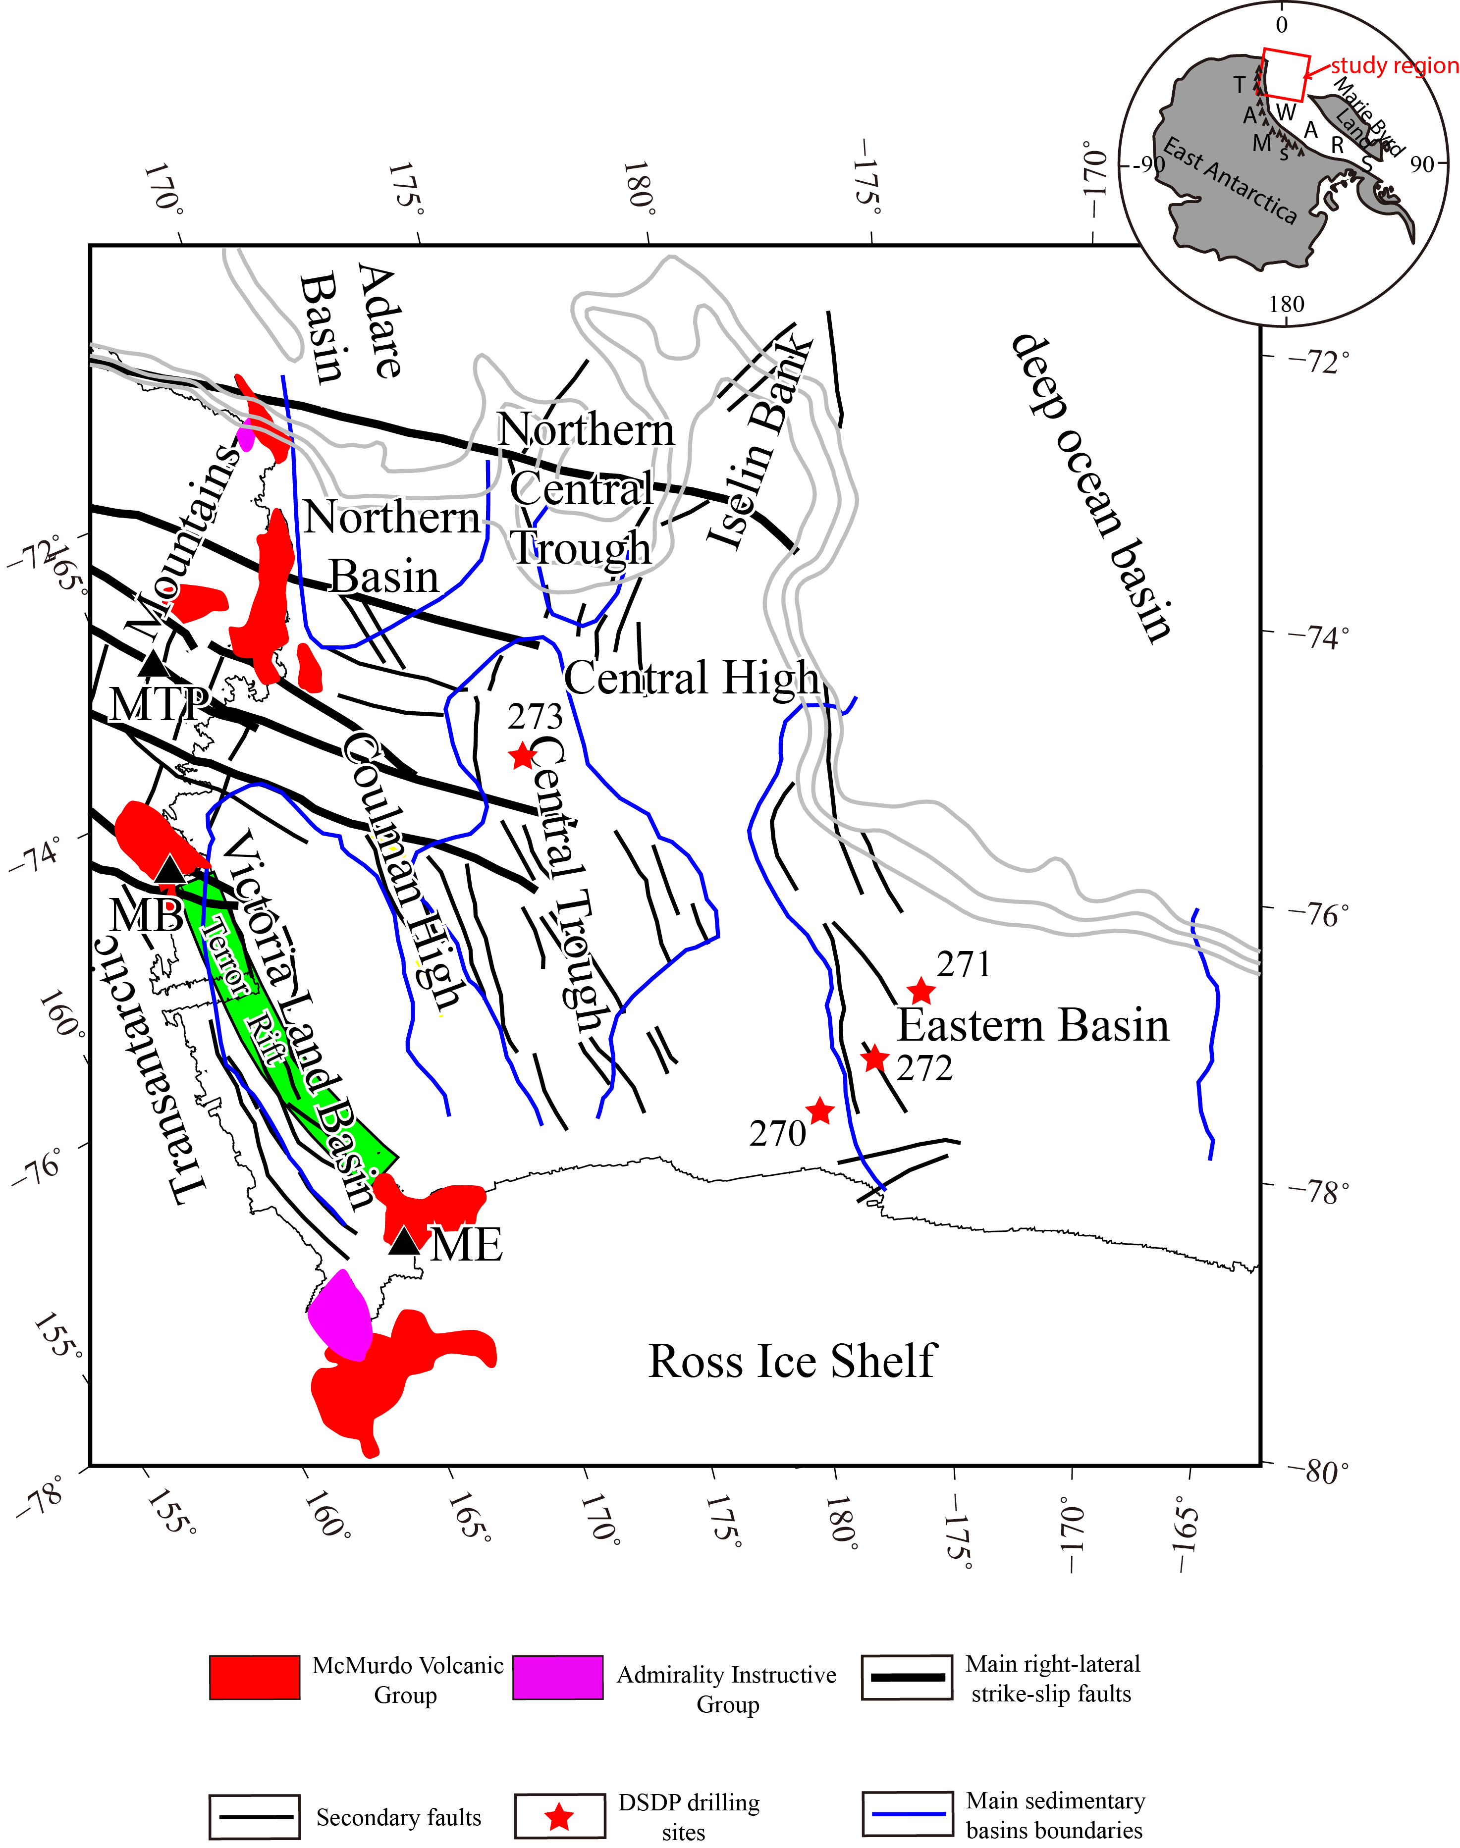

**Fig. 1.** Geological map of the Ross Sea region showing the location of the TAMs, the Ross Sea Shelf, DSDP drilling sites, basement rises and sedimentary basins. The 1000-m, 1500-m and 2000-m isobaths indicate the location of the continental slope. The thin black line indicates the coastline of Victoria Land. Main right-lateral strike-slip faults (solid black lines) and secondary faults are redrawn from Salvini *et al*. (1997). Abbreviations: MB, Mt. Melbourne; MT, Mt. Erebus; MTP, Mt. The Pleiades.

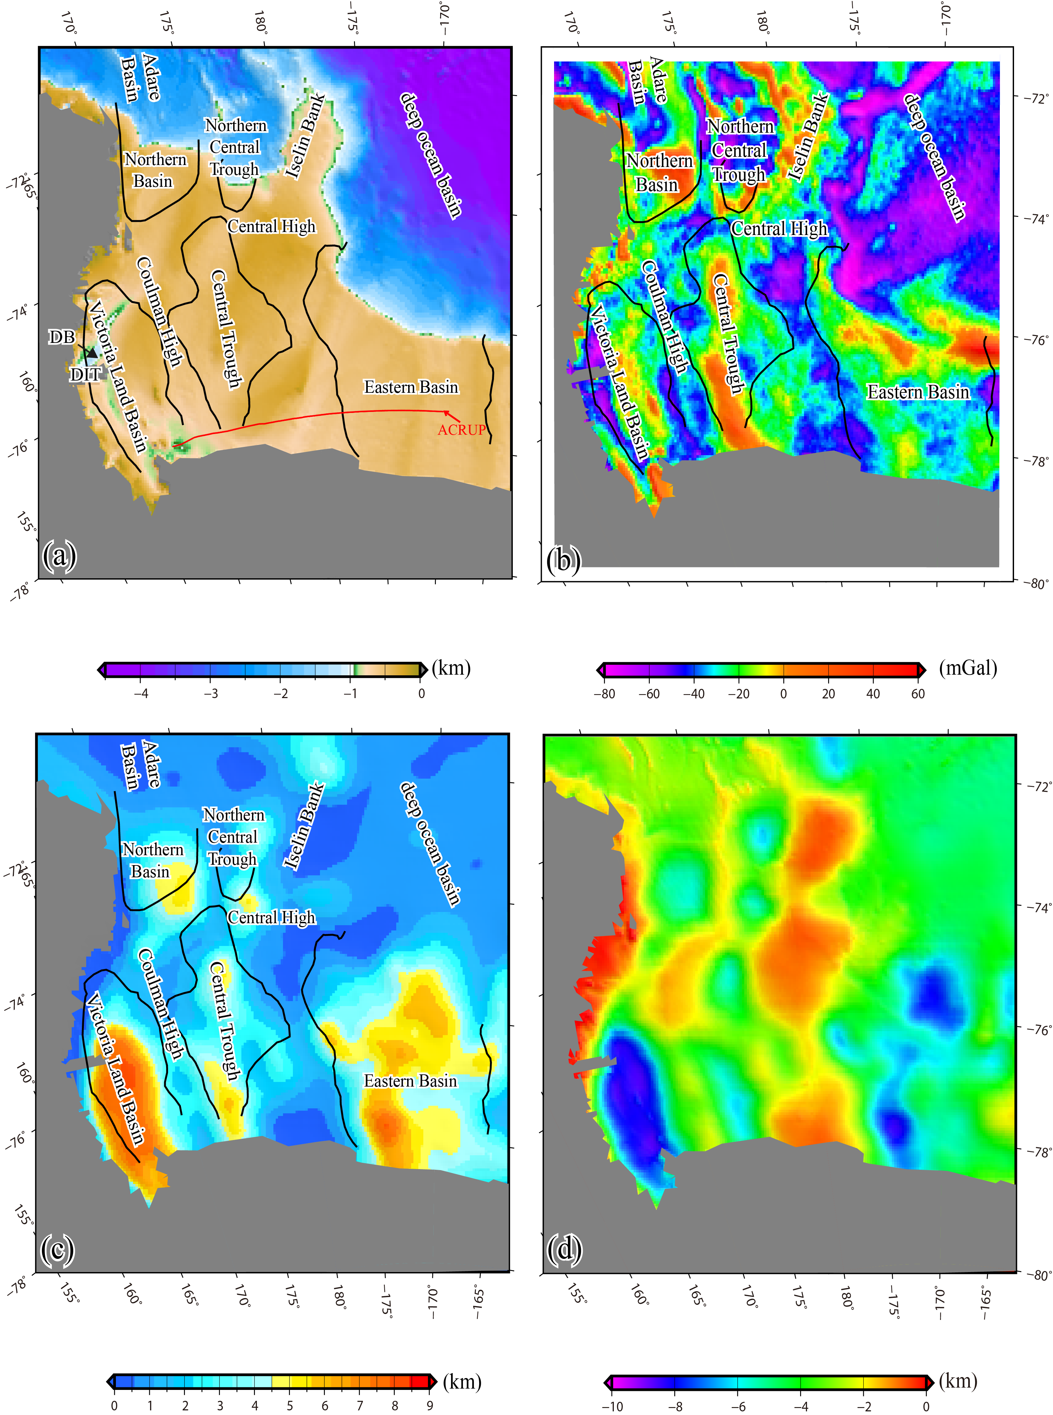

**Fig. 2.** Maps of the study region. (a) Bathymetric map based on the General Bathymetric Chart of the Oceans (GEBCO), (b) free-air gravity anomalies from FAA V23.1, (c) sediment thickness (Lindeque *et al.* 2016) and (d) depths to basement determined by subtracting the sediment thickness (c) from the bathymetry (a). The solid red line shows the location of OBS profile of ACRUP project (Trey *et al.* 1999). The tectonic lines delineating the boundary of the main basins are the same as in Fig. 1. Abbreviations are: DB: Drygalski Basin and DIT: Drygalski Ice Tongue.

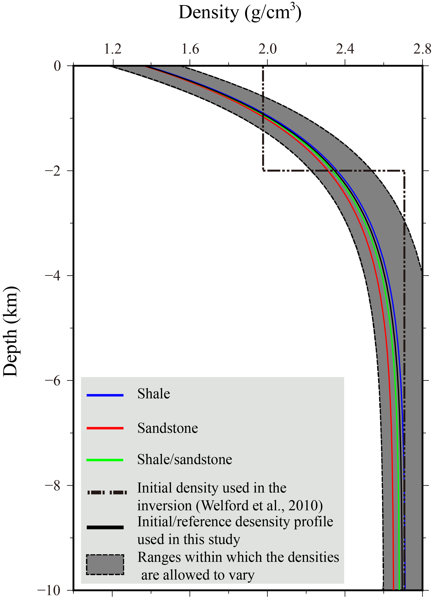

**Fig. 3.** Different theoretical models that reflect variations in density with depth. In the gravity inversion, we employ the sediment compaction model as the initial and reference model, and the envelope defined by the upper and lower boundaries within which the density is allowed to vary is denoted by the grey region.



**Fig. 4.** Oblique perspective view of the 3-D density anomaly model obtained via gravity inversion over the Ross Sea region. In the inversion, the land area and the Ross Ice Shelf are excluded. We show the inverted 3-D density anomaly model with this orientation of the axes to better display the internal density variations.

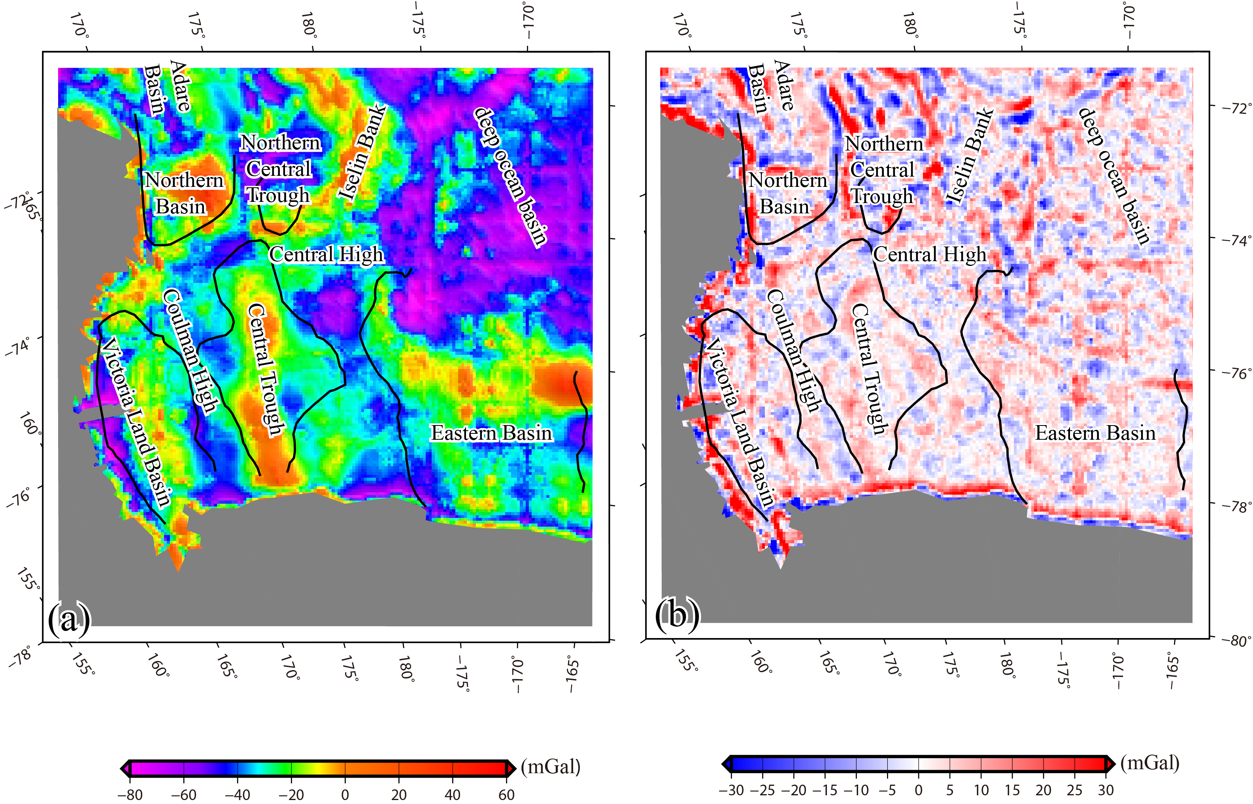

**Fig. 5.** (a) Predicted free-air gravity anomalies based on the inverted 3-D density model shown in Fig. 4. (b) Differences between the observed free-air gravity anomalies and the predicted values.

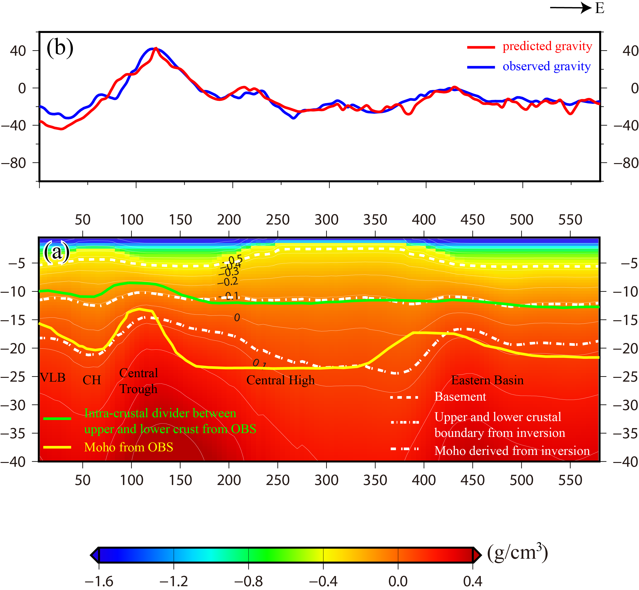

**Fig. 6.** Cross-section of the inverted 3-D density anomaly model along the ACRUP profile (its location is shown in Fig. 2a) (a) and the corresponding discrepancies between the observations and calculations (b). Abbreviations: CH, Coulman High.

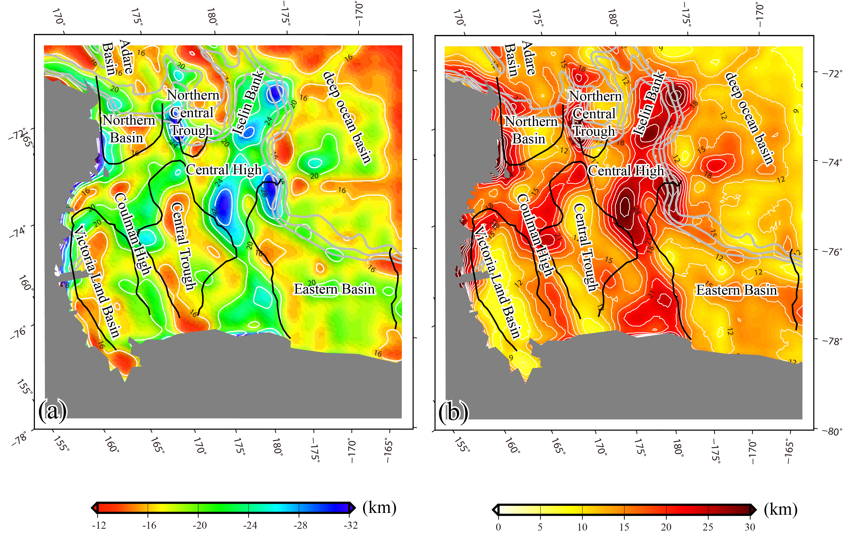

**Fig. 7.** The Moho depth surface (a) and crustal thicknesses (b) extracted from the inverted 3-D density anomaly model combined with the evidence from ACRUP (Fig. 7).

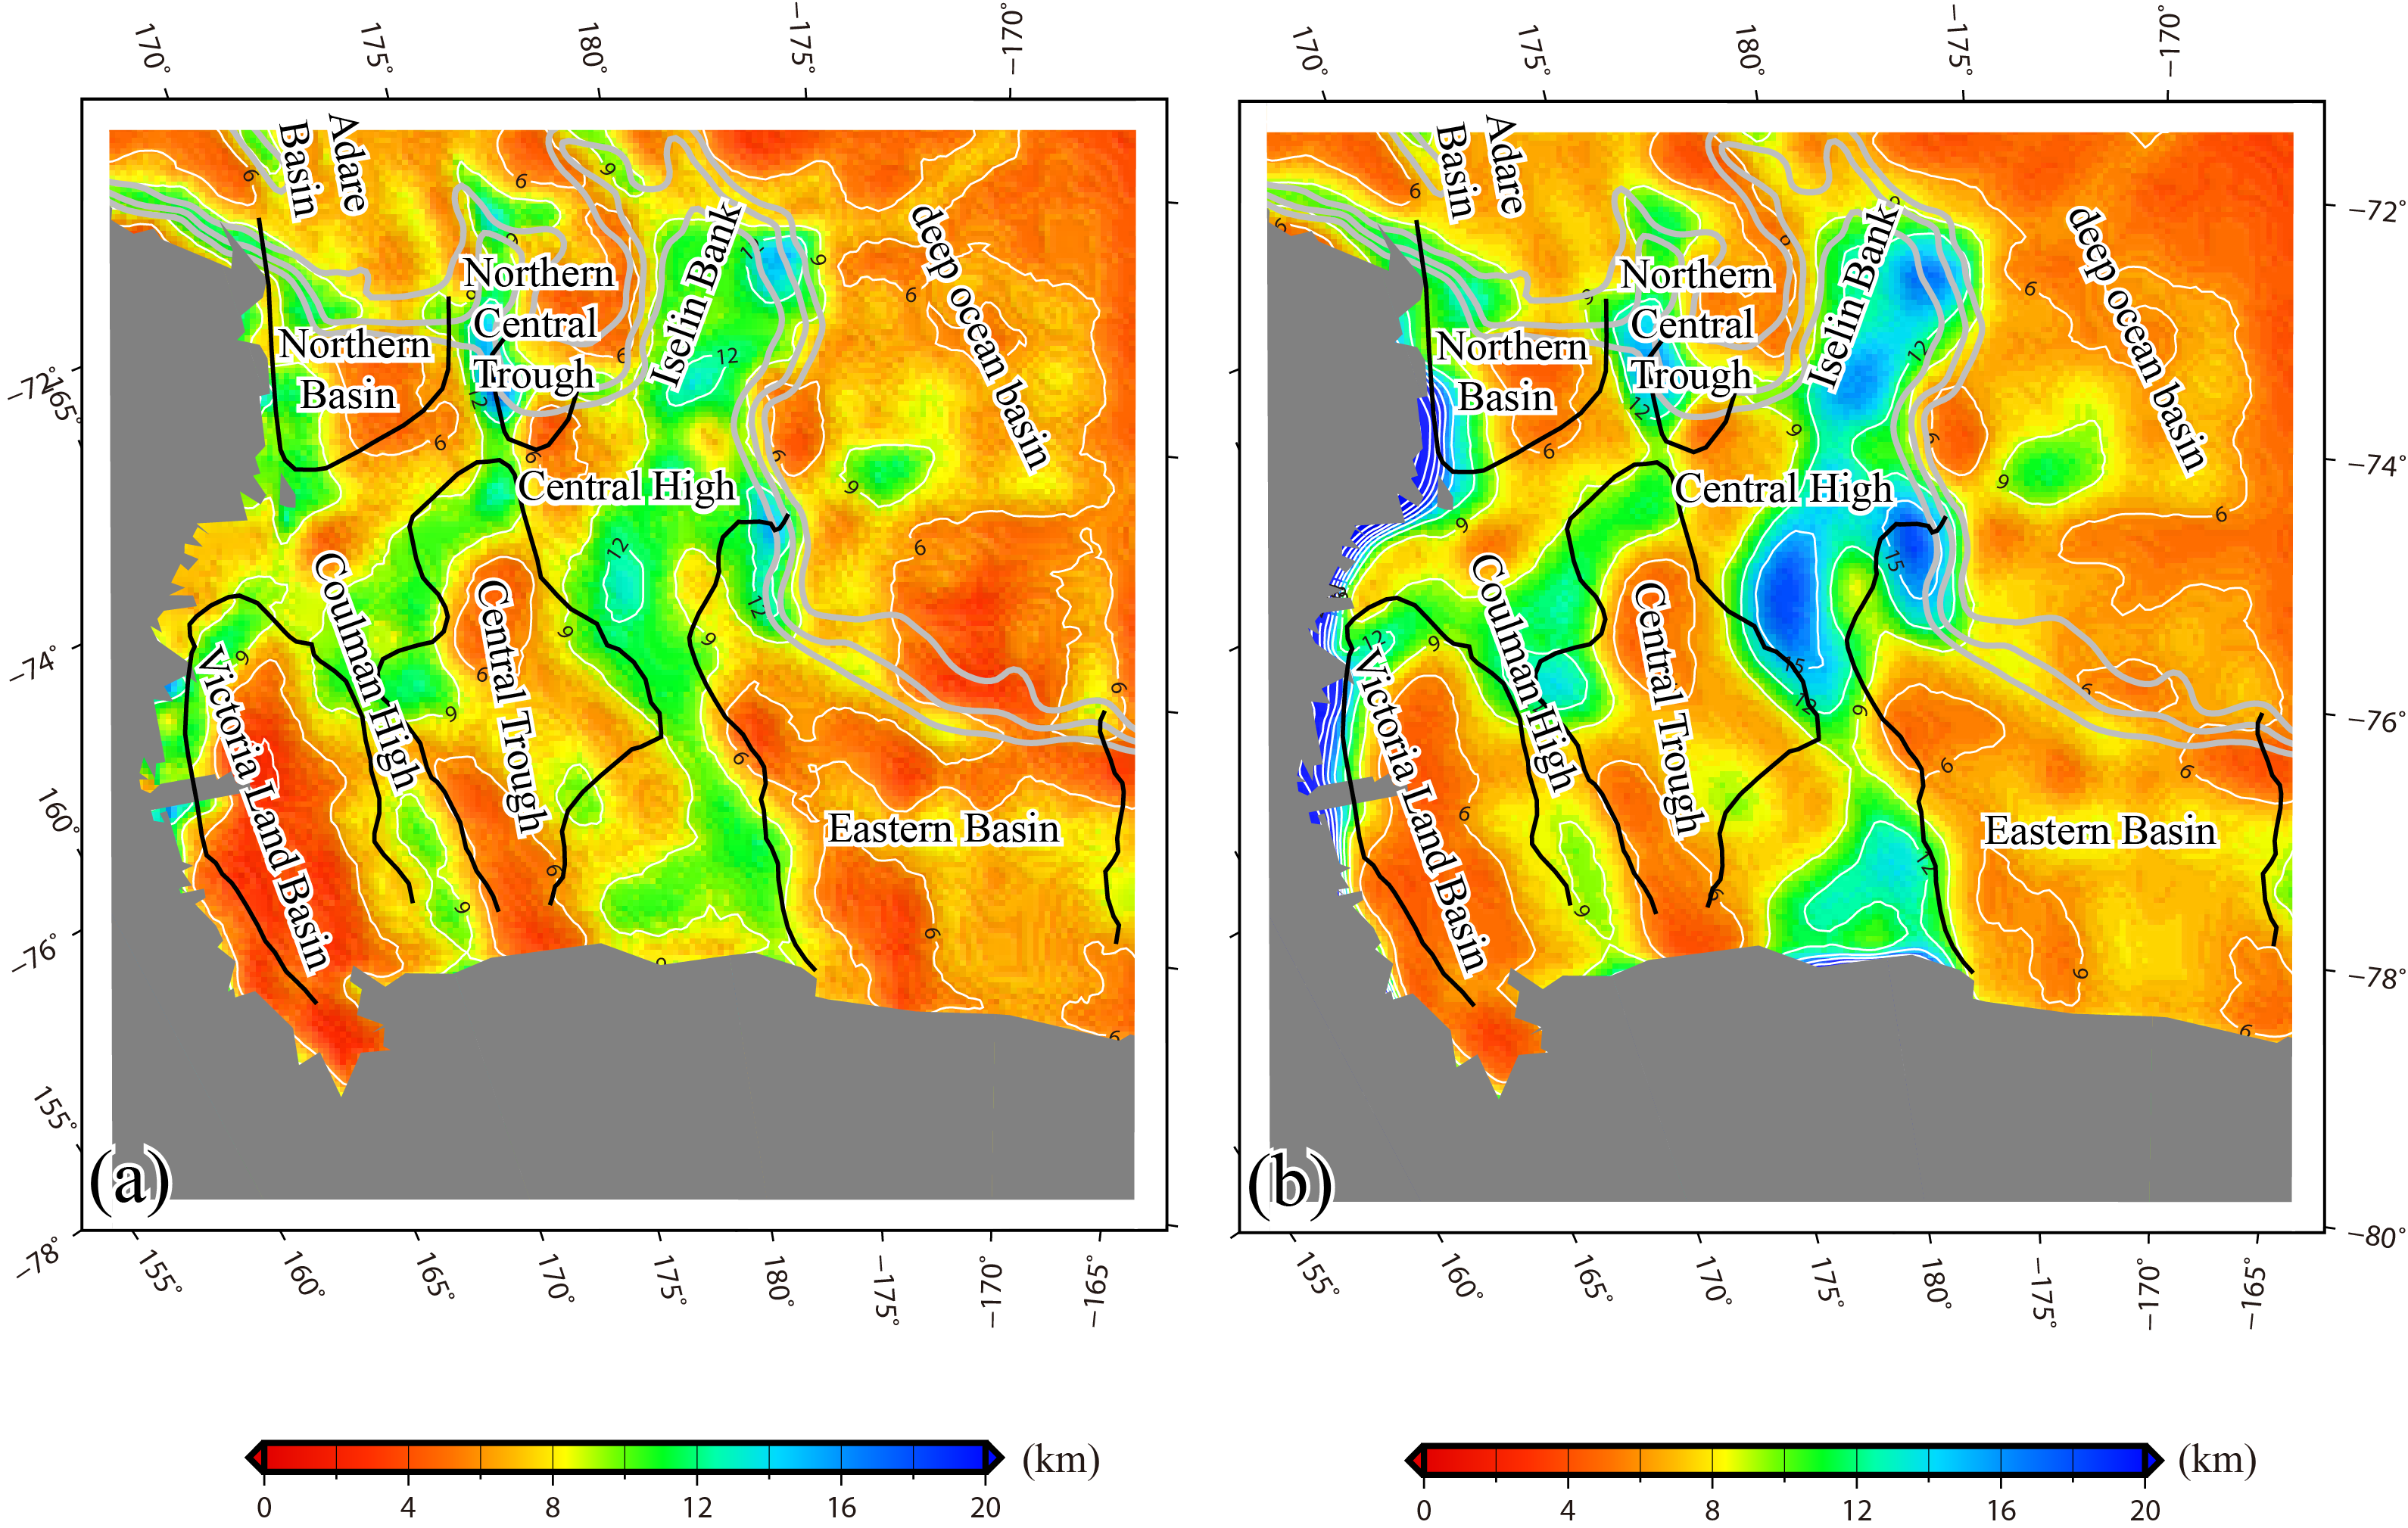

**Fig. 8.** The thicknesses of the upper crust (a) and the lower crust (b) referencing the intra-crustal boundary (the 2710 kg/m3 density contour extracted from the inverted 3-D density anomaly model shown in Fig. 4) of the OBS profile from ACRUP.

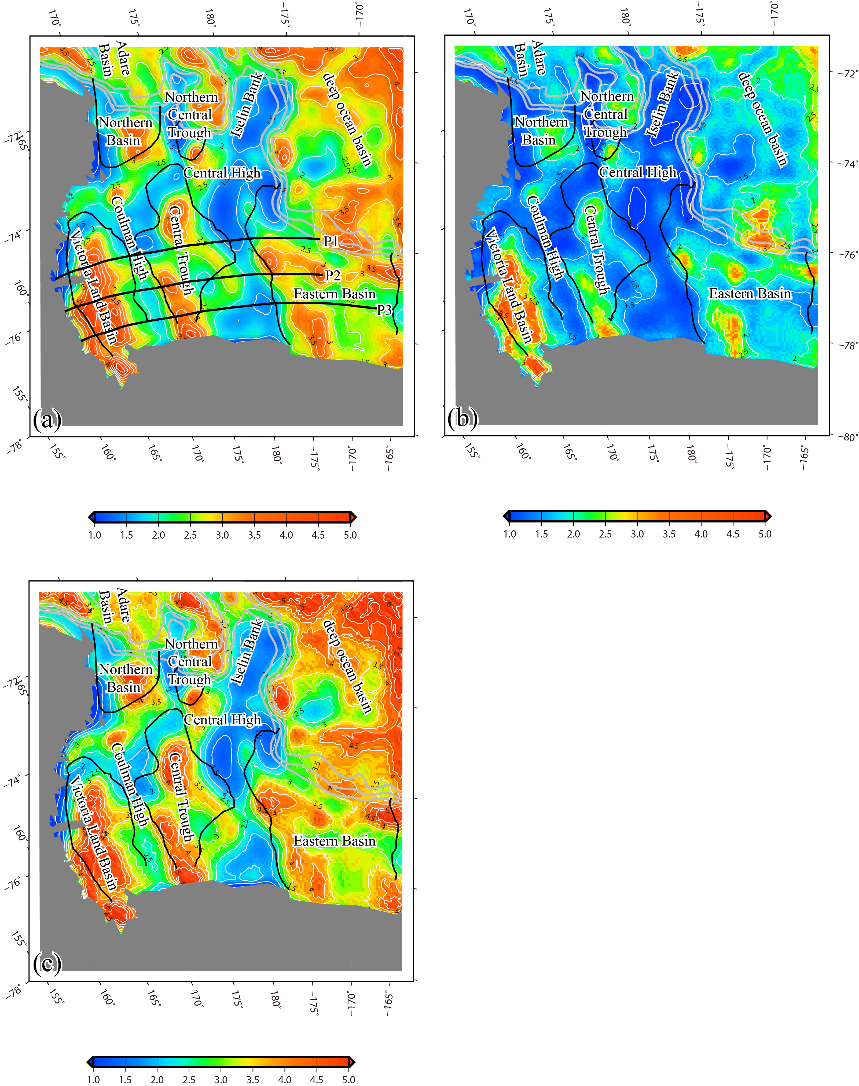

**Fig. 9.** The distributions of *βw* (a), *βu* (b) and *βl* (c) obtained by assuming initial thicknesses for the crust as a whole and the upper and lower crust of 35 km, 12 km and 23 km, respectively. The black lines in Fig. 9(a) indicate the traces of profiles shown in Fig. 10. Tectonic lines are the same as in Fig. 1.

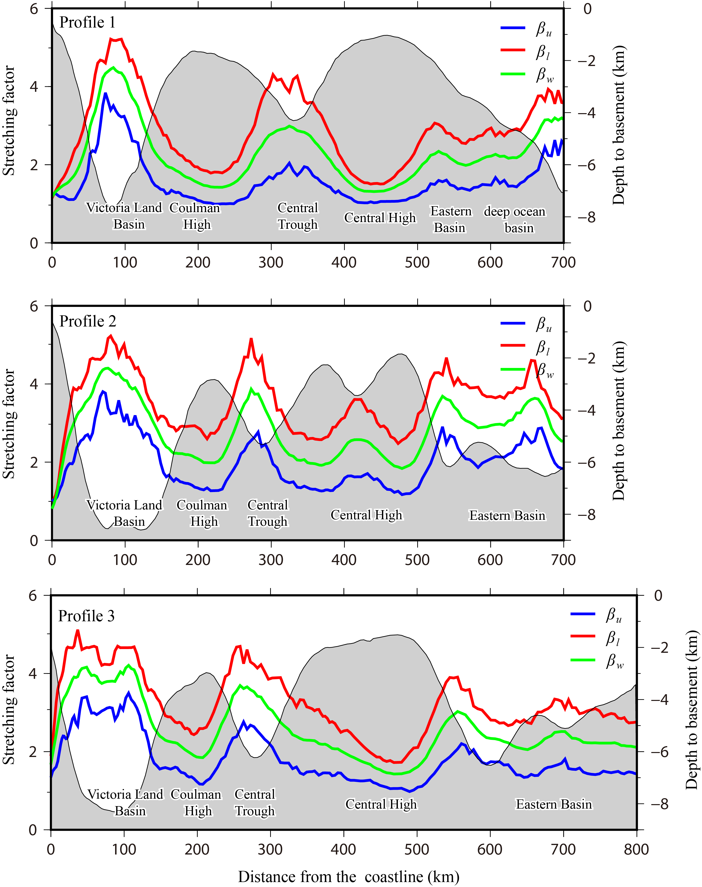

**Fig. 10.** The distributions of stretching factors within different individual crustal layers and the depths to basement along three east-west-trending profiles across sedimentary basins in the Ross Sea. The profile locations are shown in Fig. 9a.

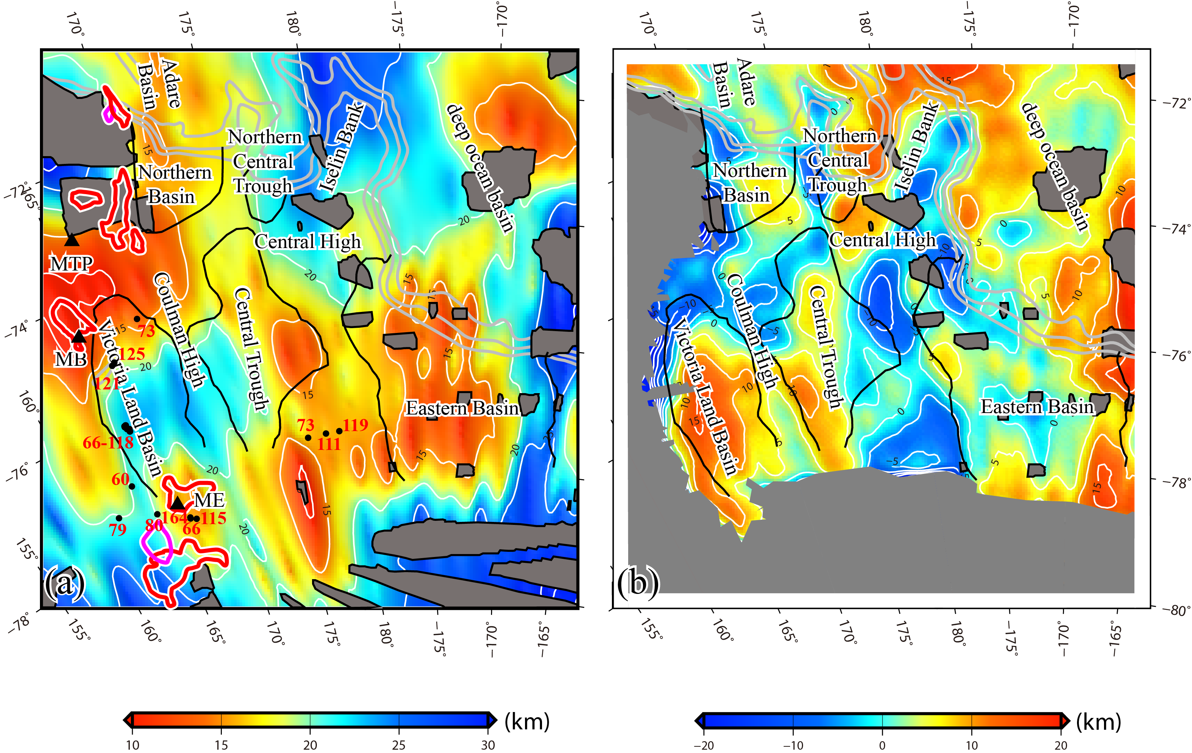

**Fig. 11.** Maps showing the distributions (a) of Curie point depths in the Ross Sea from Li *et al*. (2017), in which the superimposed black dots display the locations of the measured heat flow values from The Global Heat Flow Database (http://www.heatflow.und.edu/index2.html). The irregular grey areas indicate the blank areas in the magnetic anomaly data used by Li *et al*. (2017). For abbreviations and other symbols, please refer to Fig. 1. The differences between the Curie point depths and Moho depths (b). For positive values, the Curie point is deeper than the Moho and vice versa.